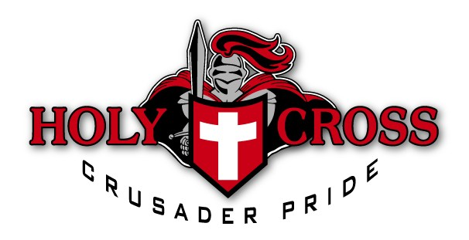

Junior Crusaders Volleyball

Grades 4 & 5

April 13-June 1
Saturdays @ 9:30-11:00
Holy Cross High School
Cost: $130
Email jrcrusadervolleyball@gmail.com to secure a spot by April 1.
Registration form here

The Junior Crusader Volleyball program is geared for girls in grades 4 & 5 who want to learn the game and gain skills. For most, this will be their first introduction to the sport, so there will be a great focus on fun while learning new skills. The play will be adapted to their age level with a focus on multiple touches of the ball. This is a great opportunity to make new friends while having fun playing volleyball!
Any questions, please contact Bree Grandia (Program director/teacher) bgrandia@holycross.bc.ca or jrcrusadervolleyball@gmail.com

